Civil war in Liberia

UNSC Resolution: | 985
Date of adoption: | 13-Apr-1995
Operative paragraph: | 2
Demand number: | 985,0211

Sarah-Myriam Martin-Brûlé

Wording of demand

implement the Akosombo Agreement (S/1994/1174) and the Accra Agreement (S/1995/7) by re-establishing an effective cease-fire, promptly installing the Council of State, and taking concrete steps towards the implementation of the other provisions of the Agremeents

List of addressees of the demand

National Patriotic Front of Liberia, Government of Liberia, Central Revolutionary Council of the National Patriotic Front of Liberia, Lola Defence Force, Liberian National Conference, Liberian Peace Council, United Liberation Movement of Liberia for Democracy - Krahn, United Liberation Movement of Liberia for Democracy - Mandingo

Short-term compliance

Description of the addressee(s)’ conduct

On September 1 (1995) the Council of State was inaugurated in Monrovia’s grand Centennial Hall. (…)
“The Presence of warlords in government did not, however, have the expected result of achieving peace in Liberia. Fighting continued between the LPC and NPFL in the southeast; between the two wings of ULIMO in the west around the Lofa Bridge; and between NPFL and ULIMO-K in Gbarnga, Suacoco and St.Paul River Bridge in Bong County.” Adebajo 2002, p.183.

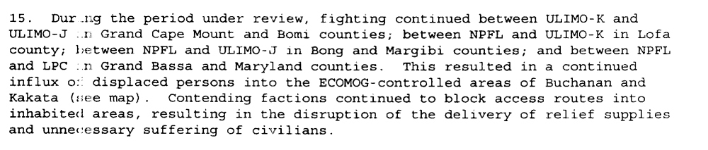
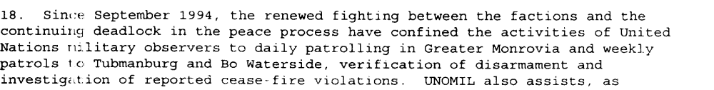
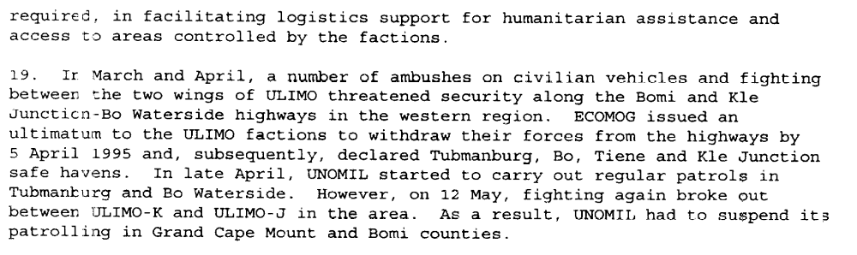
S/1995/473 (10 June 1995)

Assessment

Short-term compliance
No or marginal compliance (1) | Medium low compliance (2) | X Medium high compliance (3) | Full or almost full compliance (4)

Considerations underlying the assessment

The signing of the Abuja Agreement, which was mostly a reaffirmation of Akosombo and Cotonou agreements translates in the demand addressees adhesion to the Akosombo Agreement (S/1994/1174) and the Accra Agreement (S/1995/7). The Council of States was established five months after the resolution was adopted. Yet the parties failed to re-establishing an effective cease-fire and to implementation other provisions of the Agremeents

Medium-term compliance

Description of the addressee(s)’ conduct

“Despite all the concessions of the Abuja Agreement, a power struggle ensued soon after the signing of the agreement and the appointment of the six members of the Council of State over appointments for positions in government. Many of the government positions were allocated along factional and ethnic lines, serving the interests of the faction leaders (Sesay 1996b; Oquaye 2001). Fighting broke out on several fronts as groups tried to secure power over resources and territory or tried to eliminate opponents: ULIMO-J attacked ECOMOG in December 1995 over control of diamond mines and disarmament, resulting in the suspension of ECOMOG’s disarmament program.

Taylor’s decision to send his own forces to arrest Johnson was viewed as the start of a campaign to eliminate his opponents (ibid; Gberie 2005b; Bekoe 2003; Adibe 1997). This was supported by ECOMOG, from whom Johnson (likely in alliance with the NPFL) had stolen equipment (Bekoe 2003).

In the ensuing fighting in Monrovia, George Boley left the Council of State and joined forces with Johnson. The fighting facilitated by the fact that the factional militias had been allowed to enter the capital after the signing of the agreement
rather than disarming them outside the capital (creating a large security problem in the capital with increasing numbers of armed fighters entering Monrovia), and by the fact that ECOMOG and UNOMIL continued to be weak and under-funded (Sesay 1996b; Reno 2004; Alao 1996). Fighting then broke out within the NPFL, between the NPFL and ULIMO-K, and between ULIMO-J, LPC, and elements of the AFL over territorial control in April 1996. The
Abuja Agreement was effectively broken, leading to the signing of the Supplement to the Abuja Accord (known as Abuja II), which was signed on 17 August 1996.

Abuja II replaced the head of the Council of State with Ruth Perry, the country’s
first female head of state. The agreement contained threats regarding asset-freezing and the establishment of war crimes tribunals to try warlords who continued fighting, but also provided for disarmament and demobilization; the dissolution of all factional militia; and for elections in May 1997, which Charles Taylor won (Sesay, 1996b). Taylor dominated the Council of State, and used his position in government as a platform to campaign during the elections (Oquaye 2001; Sesay 1996b). The ECOMOG-enforced peace in Liberia meant that Taylor’s opponents could not re-arm and Taylor’s position in government allowed Taylor to intimidate, disarm and eliminate his enemies and civilian critics in the name of keeping the peace as he continued down the political path and prepared for the elections. The external guarantors of the 1995 agreement failed to constrain Taylor in his actions, since they realized that peace could not be won without him (Reno 2004).
Though the Abuja II Agreement was the last agreement signed of the first period of Liberia’s civil war, and ended in successful elections, these elections also brought the country’s strongest warlord to power. This would prove detrimental to the stability of the country, as Taylor’s presidency spawned the birth of two new ULIMO-based rebel groups who reignited the conflict to rid the country of Taylor. (Dupuy & Detzel, 1997 p.14-15)

“The Abuja Agreement was largely a reaffirmation of Akosombo and Cotonou. However, the renewed hostilities in Liberia in April 1996 appear to have created a major setback for the peace process.”

Olonisakin, Funmi(1996)'UN co-operation with regional organizations in peacekeeping: The experience of ECOMOG and UNOMIL in Liberia',International Peacekeeping,3:3,33 — 51
http://pdfserve.informaworld.com/956505_751319779_784175576.pdf

Assessment

Medium-term compliance
No or marginal compliance (1) | X Medium low compliance (2) | Medium high compliance (3) | Full or almost full compliance (4)

Considerations underlying the assessment

The signing of the Abuja Agreement, which was mostly a reaffirmation of Akosombo and Cotonou agreements translates in the demand addressees adhesion to the Akosombo Agreement (S/1994/1174) and the Accra Agreement (S/1995/7). The Council of States was established five months after the resolution was adopted. Yet the parties failed to re-establishing an effective cease-fire and to implementation other provisions of the Agremeents

Depth of demand

Assessment

Level of depth of demand
Low depth of demand (1) | X Medium depth of demand (2) | High depth of demand (3)

Considerations underlying the assessment

The signing of the Abuja Agreement, which was mostly a reaffirmation of Akosombo and Cotonou agreements translates in the demand addressees adhesion to the Akosombo Agreement (S/1994/1174) and the Accra Agreement (S/1995/7).

“The logic of Abuja accord was to give to the armed factions joint control of the government of Liberia, encouraging them to pursue by political means the interest which they had previously contested in battle. This soon led to antagonism(…) it also offered all the factions a chance to occupy government positions. (…) The various factions could now combine control of the resources of the hinterland with opportunities offered by access to the facilities of a sovereign state. (Ellis 1999: 107).”

Taylor had lost a good deal of territory to the other factions, making conditions right for another peace deal (Adebajo 2002; Adibe 1997). Taylor’s realization that he could not militarily take Monrovia alone.

Level of confidence about coding decisions

Level of confidence about coding decision
Extremely high | High | X Moderate

Comments to IPI (if any)

